Date: 2016.09.19

ASR 6324

CTM Import:

1. Add Column FG Material no
2. Auto generate Pick list email – Pick list by FG Material No sort by Location

WMS Changes:  
Sample Import file: CTM

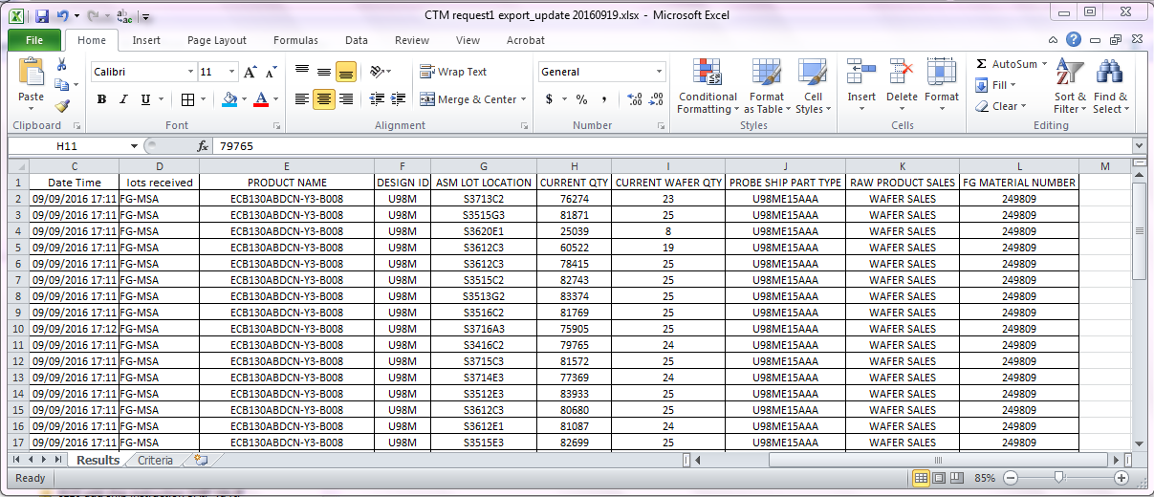

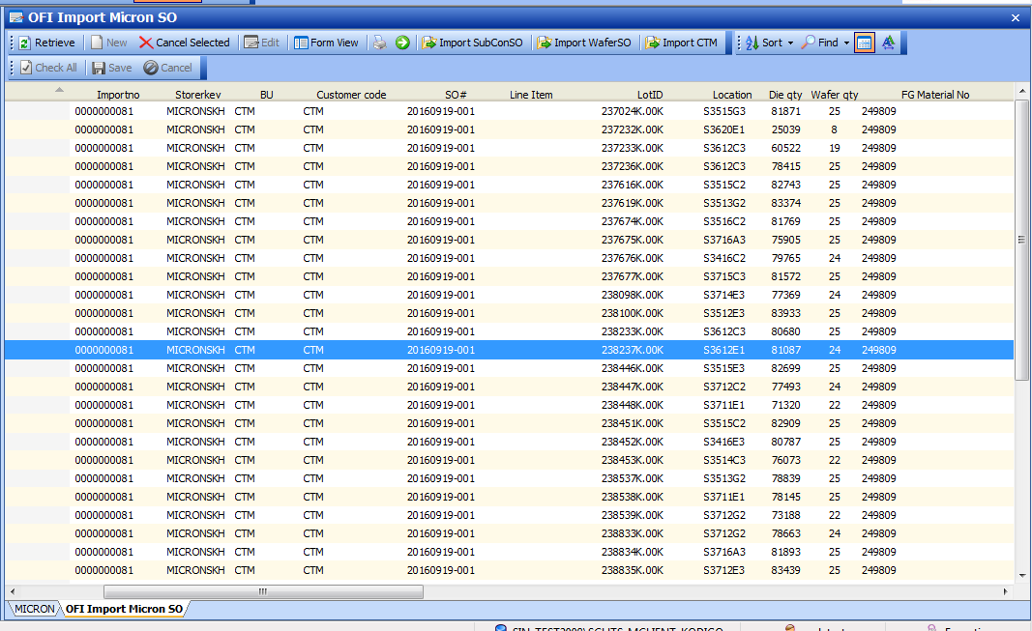

Pick list CTM

Auto-email

